Task on CloudTrail & CloudWatch
- Enable CloudTrail monitoring and store the events in S3 and CloudWatch log events.

Step:1 Create an S3 Bucket (for CloudTrail logs)
- Open Amazon S3 in the AWS Console.
- Click Create bucket.
- Enter a Bucket name (example: my-cloudtrail-logs-bucket).
- Select your Region.
- Keep default settings → Click Create bucket.
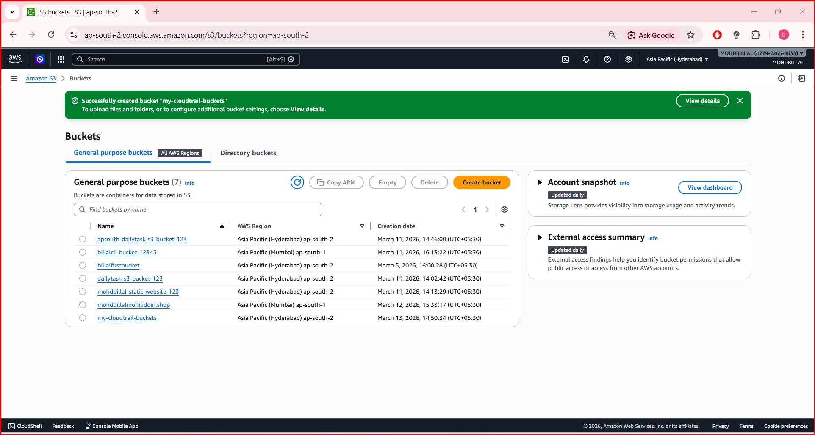
This bucket will store the CloudTrail log files.

Step:2 Create a CloudWatch Log Group
- Go to Amazon CloudWatch.
- In the left panel click Logs → Log groups.
- Click Create log group.
- Enter name: CloudTrail-Logs.
- Click Create.
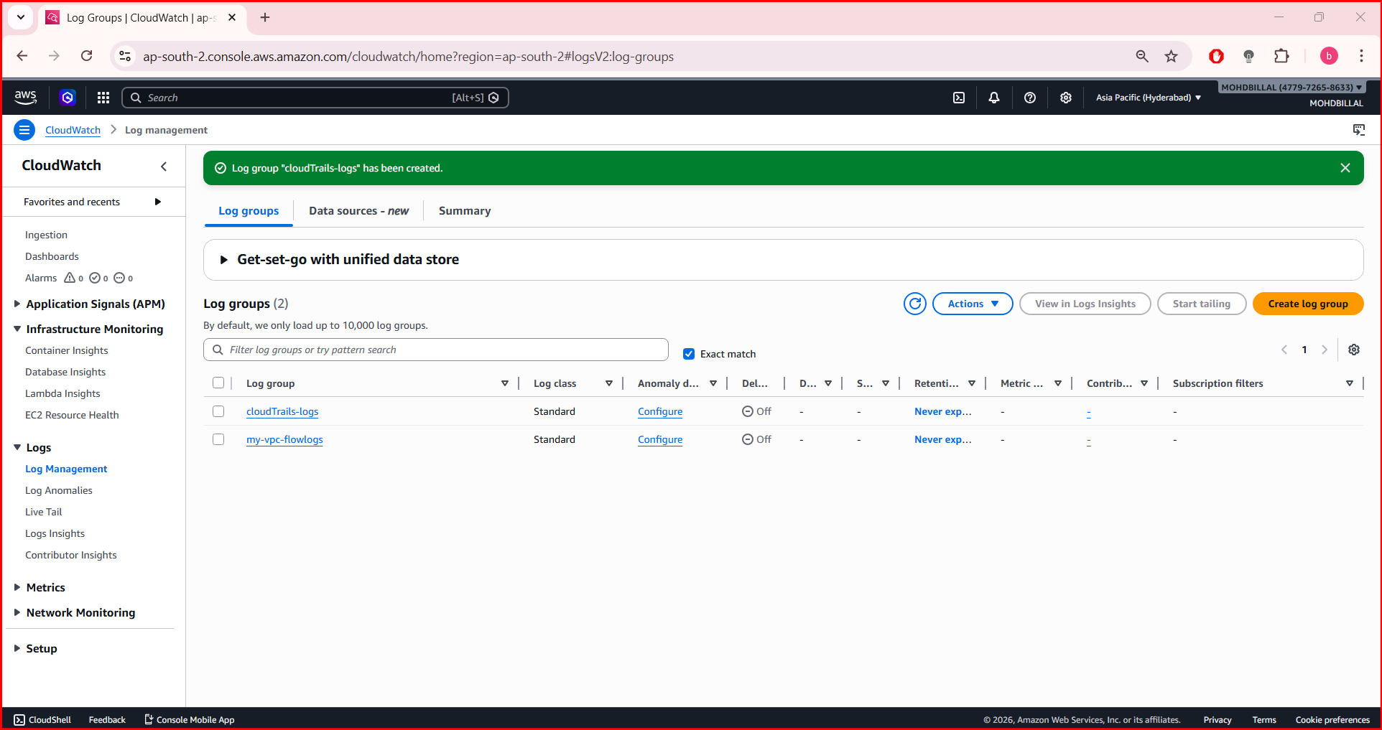

Step: 3 Enable CloudTrail
- Open AWS CloudTrail.
- Click Trails → Create trail.
Fill the details:
- Trail name: MyTrail
- Apply trail to all regions: Yes (recommended)
- Management events: Read/Write
- S3 bucket: Select the bucket created earlier (my-cloudtrail-logs-bucket)
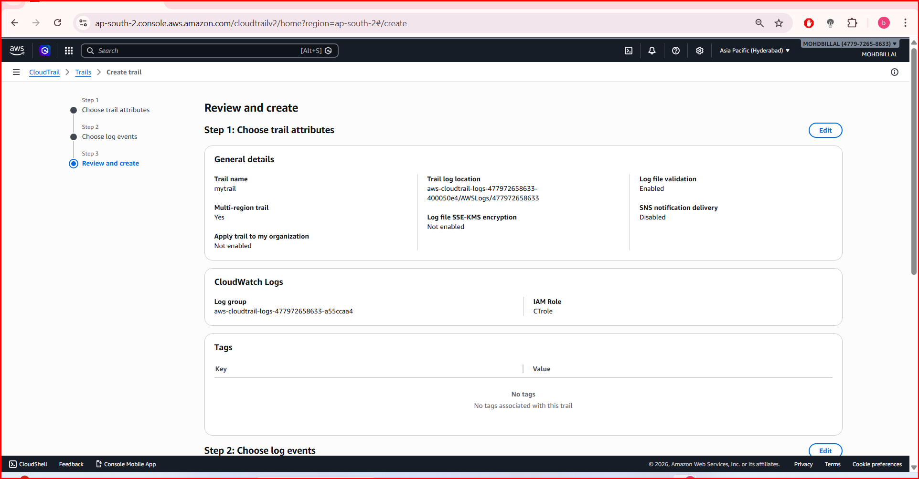

Step:4 Enable CloudWatch Logs Integration
During trail creation:
- Scroll to CloudWatch Logs section.
- Enable Send to CloudWatch Logs.
- Select:
- Log group: CloudTrail-Logs
- IAM Role: Click Create new role
AWS automatically creates the role for CloudTrail to send logs to CloudWatch.

Step:5 Create the Trail
Click Create trail.
Now:
- S3 → Stores CloudTrail log files.
- CloudWatch Logs → Shows real-time API activity logs.

Step:6 Verify Logs

Check S3
- Go to Amazon S3.
- Open your bucket → You will see folders like:
AWSLogs/
Account-ID/
CloudTrail/

Check CloudWatch Logs
- Open Amazon CloudWatch
- Go to Log Groups → CloudTrail-Logs
- Open the latest log stream to view API events.
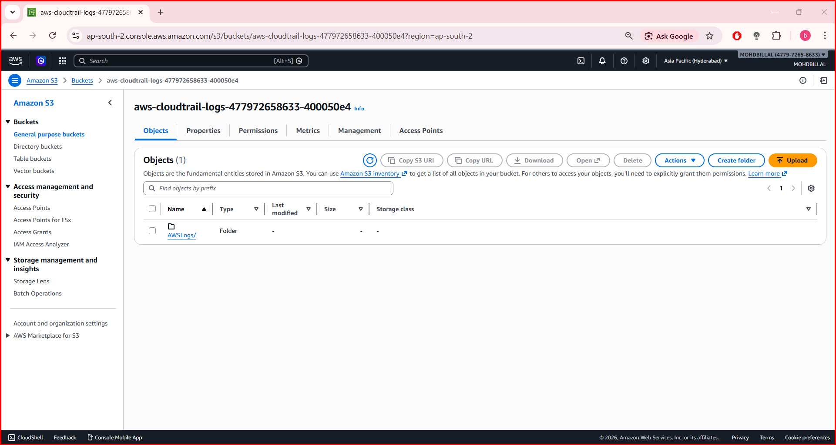
- Enable SNS for CloudTrail to send alerts via email.

Step: 1 Create an SNS Topic
- Open Amazon SNS.
- Click Topics → Create topic.
- Choose Standard.
- Enter:
- Name: CloudTrail-Alerts
- Click Create topic.
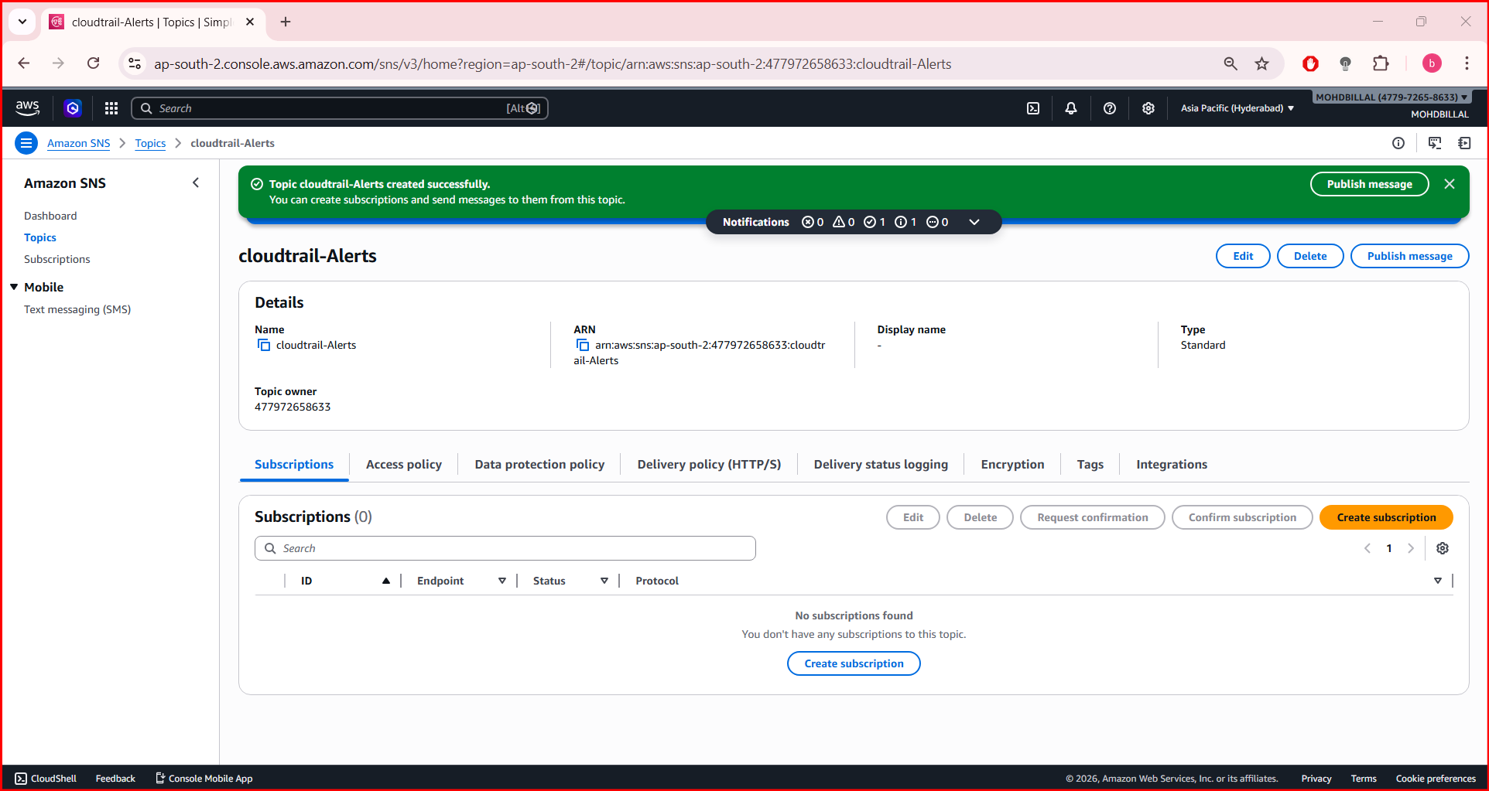

Step: 2 Subscribe Email to SNS
- Open the created topic CloudTrail-Alerts.
- Click Create subscription.
- Select:
- Protocol: Email
- Endpoint: your email address (example: yourname@gmail.com)
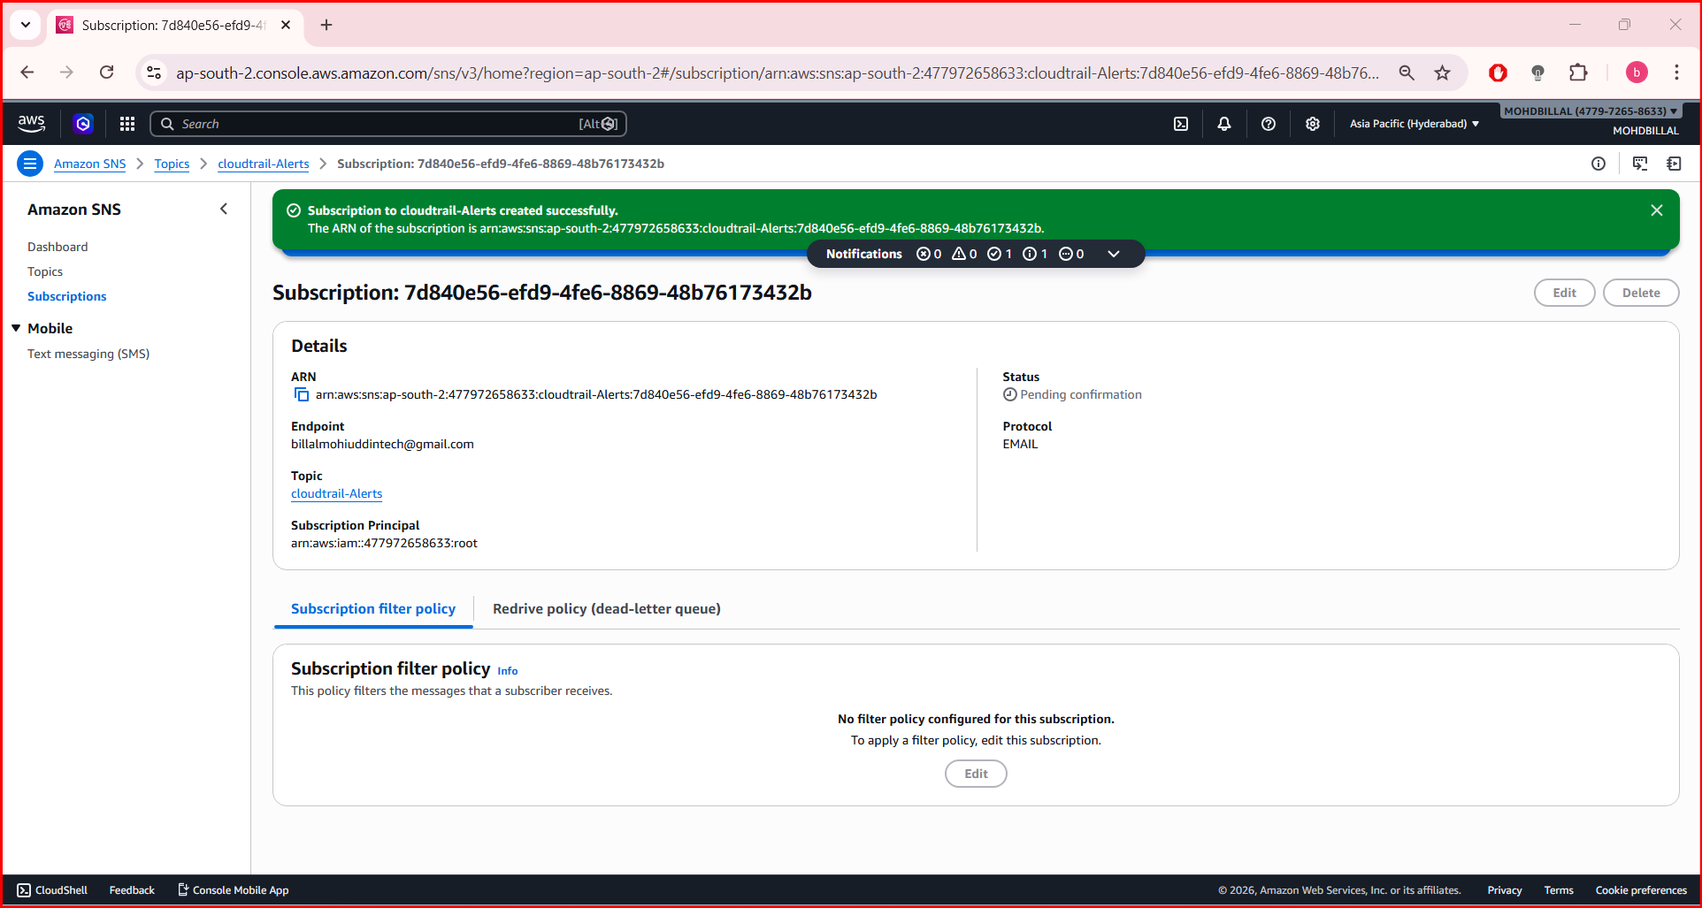

- Click Create subscription.
📧 AWS will send a confirmation email → open it → click Confirm Subscription.
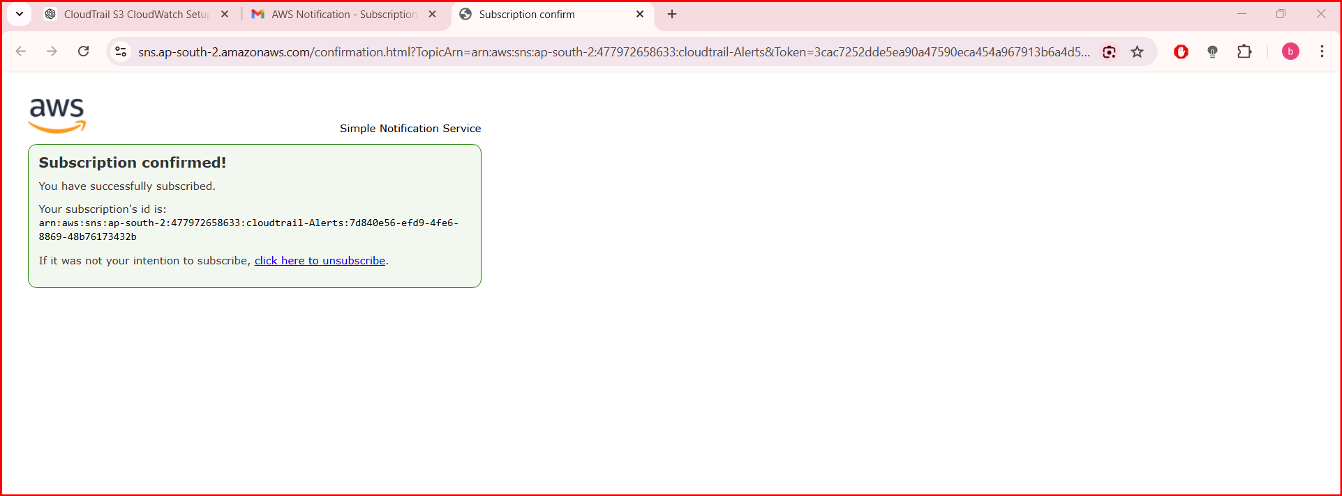

Step: 3 Create a CloudWatch Metric Filter for CloudTrail Logs
- Open Amazon CloudWatch.
- Go to Logs → Log Groups.
- Select the CloudTrail log group (example: CloudTrail-Logs).
- Click Create metric filter.
Example filter pattern for Console login events:
{ $.eventName = ConsoleLogin }
- Click Next.
Enter:
- Metric Namespace: CloudTrailMetrics
- Metric Name: ConsoleLoginCount
- Metric Value: 1
Click Create Filter.
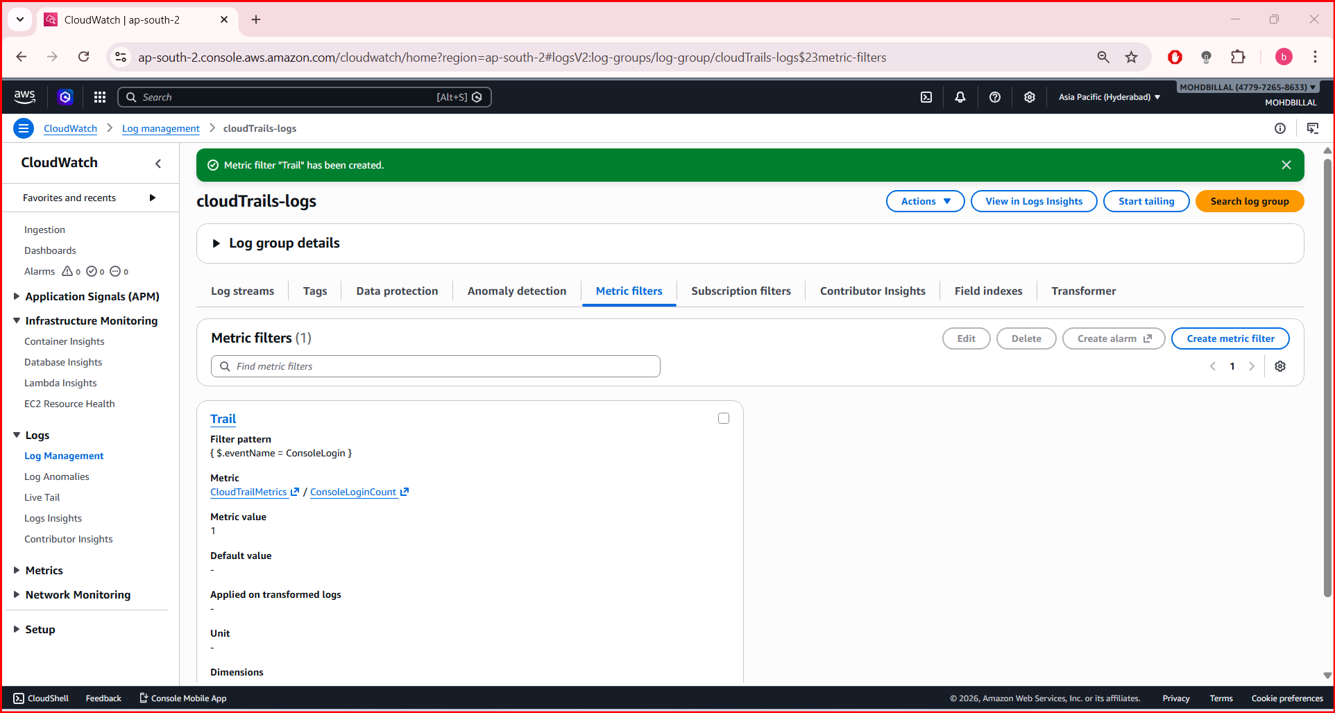

Step: 4 Create a CloudWatch Alarm
- Go to CloudWatch → Alarms.
- Click Create alarm.
- Select the metric:
CloudTrailMetrics → ConsoleLoginCount
- Configure:
- Threshold type: Static
- Whenever metric is: Greater than 1

Step: 5 Attach SNS Notification
In Notification section:
- Choose Send notification to SNS topic
- Select CloudTrail-Alerts
Click Create Alarm.
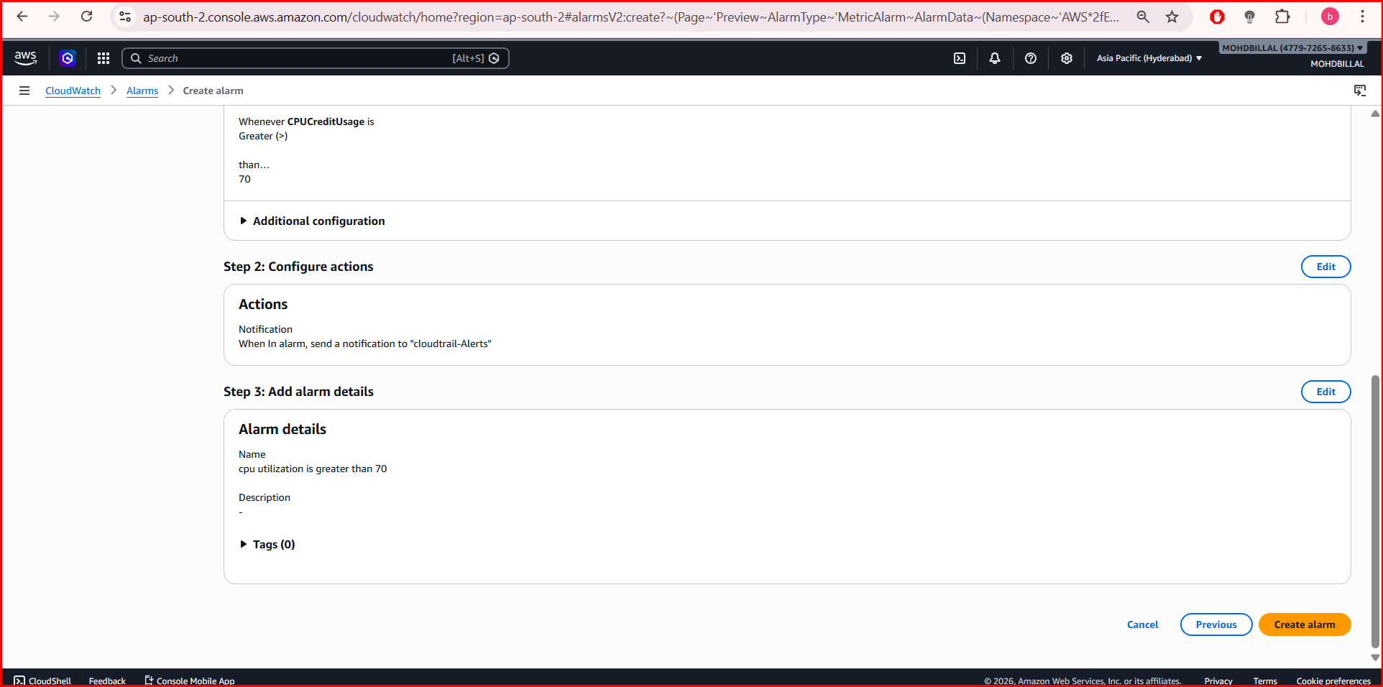

Step: 6 Test the Alert
- Login to AWS console again or trigger an event.
- AWS CloudTrail records the event.
- Amazon CloudWatch detects it.
- Amazon SNS sends an email alert.

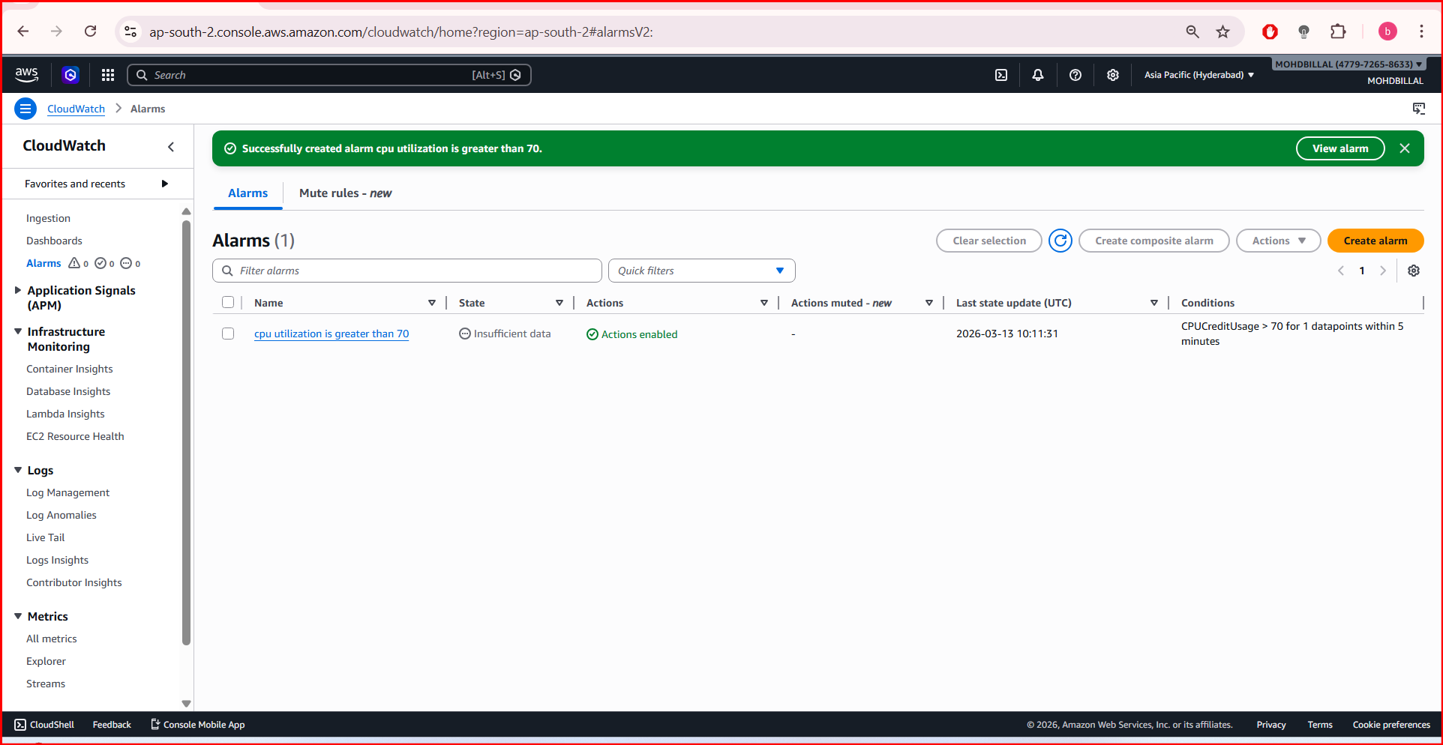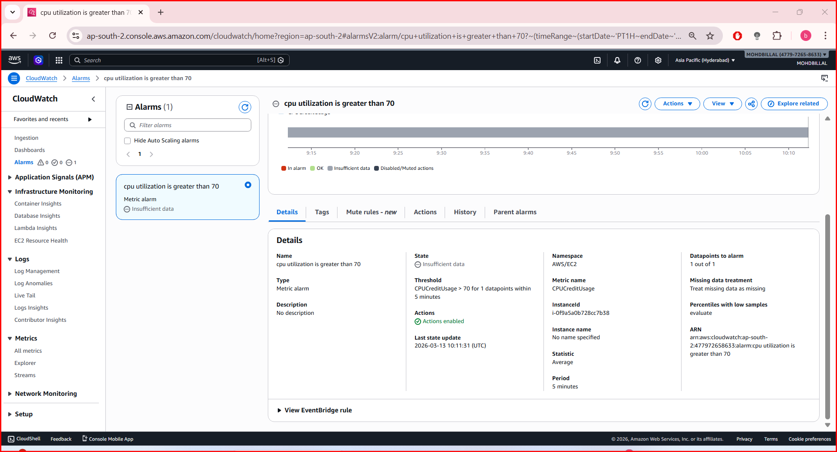

3. Configure CloudWatch monitoring and record the CPU utilization and other metrics of EC2.

Step: 1 Launch or Select an EC2 Instance
- Open Amazon EC2 in the AWS Console.
- Go to Instances.
- Select your running EC2 instance.
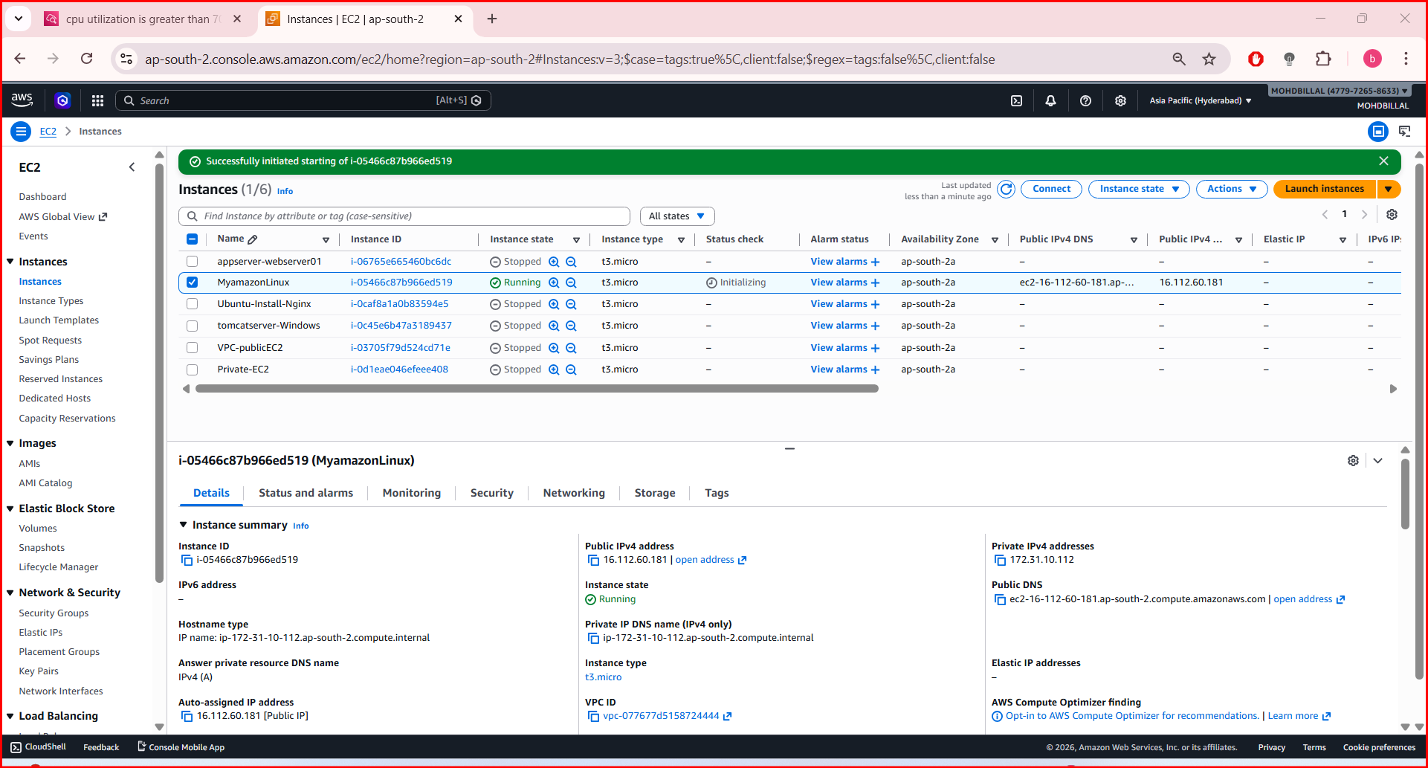

Step: 2 Check Monitoring for the Instance
- Click the Monitoring tab of the instance.
- Click View detailed monitoring in CloudWatch.
This will open metrics in Amazon CloudWatch.
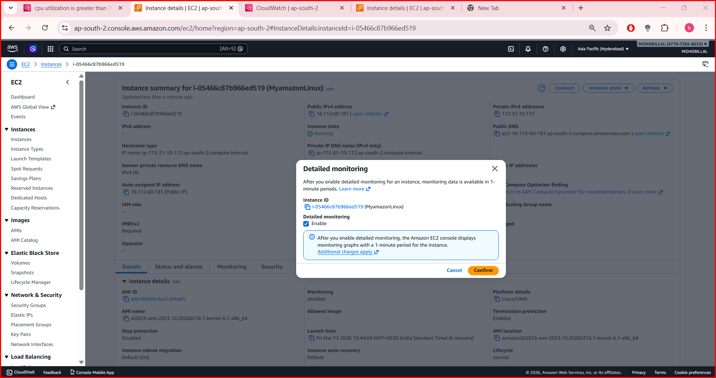

Step: 3 View EC2 Metrics in CloudWatch
- Open Amazon CloudWatch.
- In the left menu click:
Metrics
- Select:
AWS/EC2
- Click:
Per-Instance Metrics
You will see metrics like:
CPUUtilization
NetworkIn
NetworkOut
DiskReadOps
DiskWriteOps
StatusCheckFailed
These metrics are automatically recorded by CloudWatch.
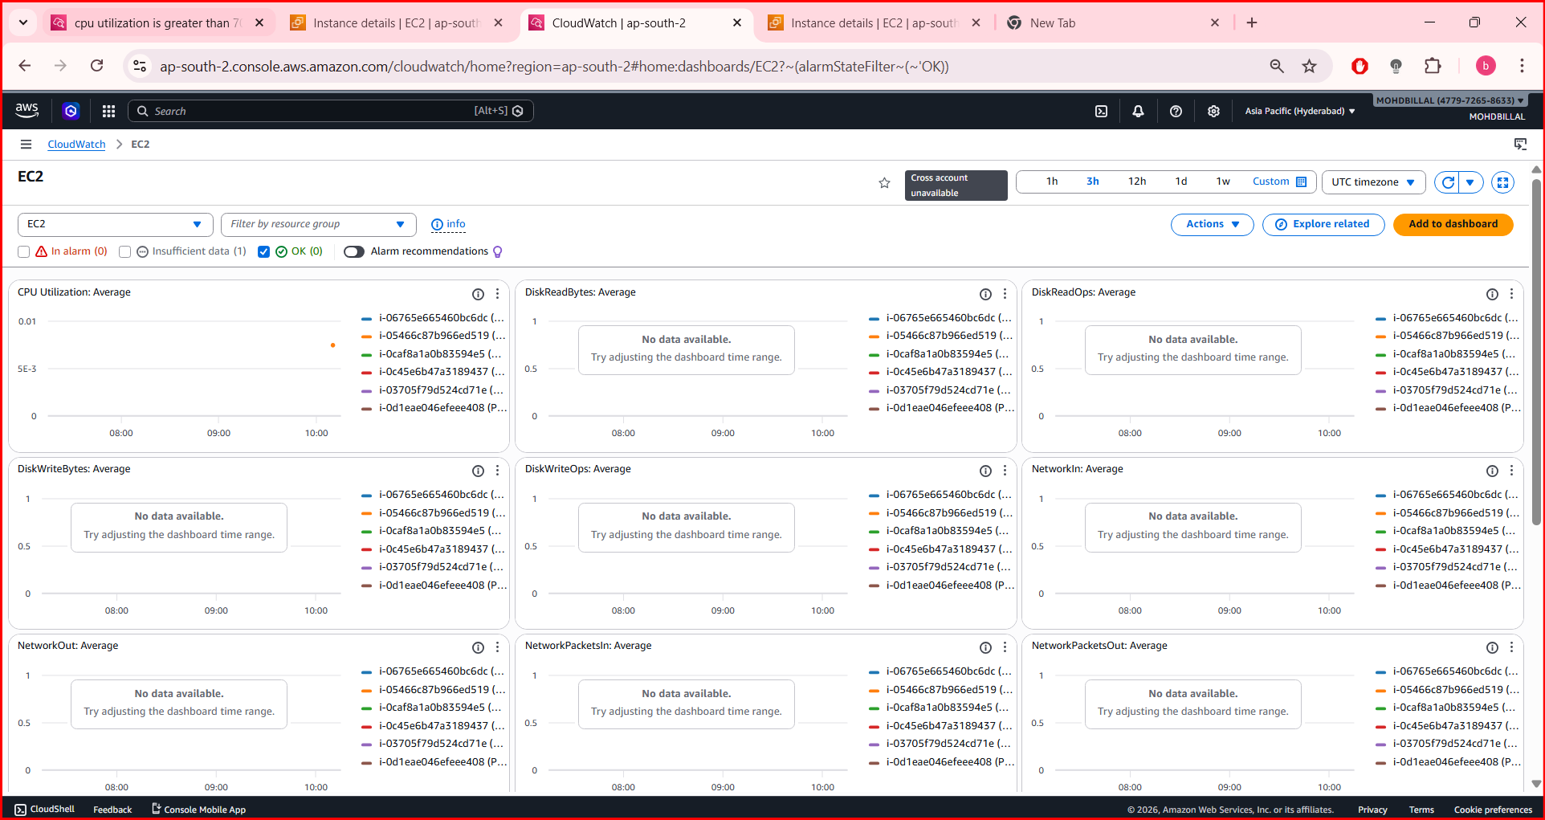

Step: 4 Enable Detailed Monitoring (Optional but Recommended)
Detailed monitoring changes metric collection from 5 minutes → 1 minute.
Steps:
- Go to Amazon EC2
- Select your instance.
- Click Actions → Monitor and troubleshoot.
- Click Enable detailed monitoring.

Step: 5 reate a CPU Utilization Alarm
- Go to Amazon CloudWatch.
- Click:
Metrics → AWS/EC2 → Per-Instance Metrics
- Select CPUUtilization of your instance.
- Click Create alarm.
Set:
Statistic: Average
Period: 5 minutes
Threshold: Greater than 70%

Step: 6 Add Notification
Attach an SNS topic from Amazon SNS so that email alerts are sent when CPU exceeds the threshold.

Step: 7 Verify Metrics
Go to:
CloudWatch
→ Metrics
→ AWS/EC2
→ Per-Instance Metrics
You will see graphs for:
- CPU Utilization
- Network traffic
- Disk operations
- Status checks


4. Create one alarm to send an alert to email if the CPU utilization is more than 70 percent.

Step: 1. Open CloudWatch
- Login to AWS Console.
- Search for Amazon CloudWatch.
- Open it.

Step: 2. Go to Metric
- In the left menu, click:
Metrics
- Select:
AWS/EC2
- Click:
Per-Instance Metrics

Step: 3. Select CPU Utilization
- Find CPUUtilization for your EC2 instance.
- Tick the checkbox.
EC2 service: Amazon EC2
- Click Create alarm (top right).
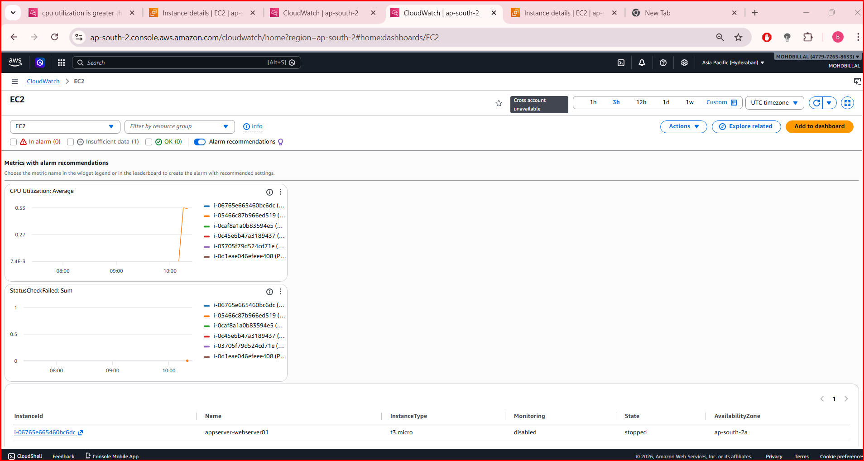

Step: 4. Configure Alarm Condition
Set the following values:
Statistic: Average
Period: 5 minutes
Threshold type: Static
Whenever CPUUtilization is Greater than 70
Click Next.

Step: 5. Configure Email Notification
- Select:
Send notification to SNS topic
- Choose the topic from Amazon SNS
Example:
Topic name: EC2-CPU-Alert
(If not created, you can create a new SNS topic and subscribe your email.)
Click Next.
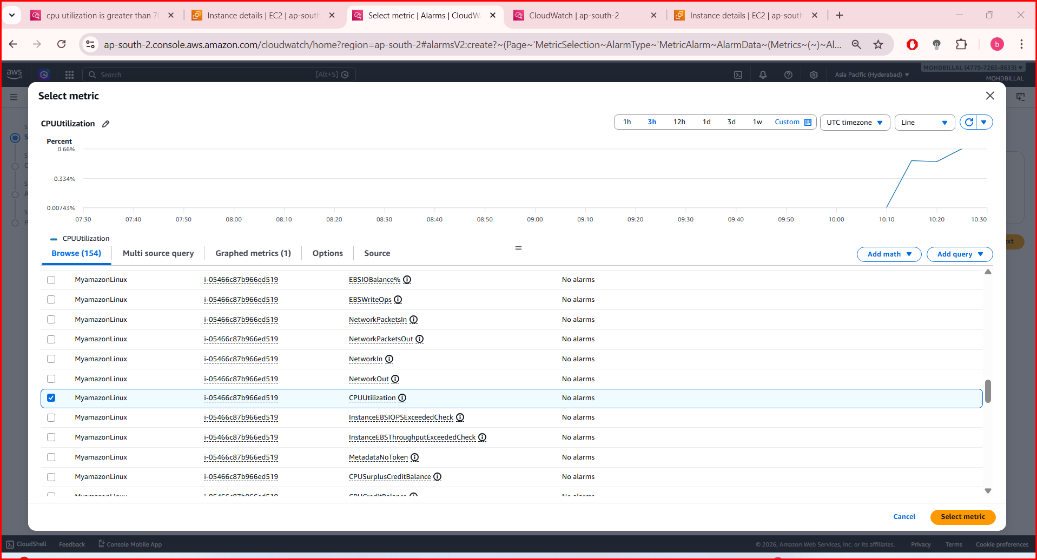

Step: 6. Name the Alarm
Example:
Alarm name: EC2-High-CPU-Alert
Description: Send email if CPU utilization exceeds 70%
Click Next → Create Alarm.
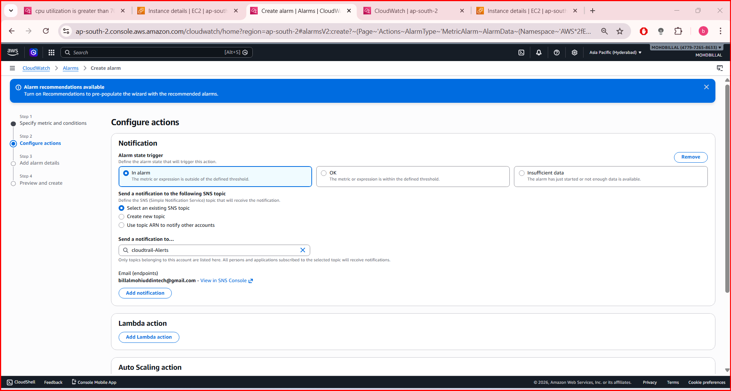

Step: 7. Verify the Alarm
Go to:
CloudWatch
→ Alarms
→ All alarms
You should see:
EC2-High-CPU-Alert
State: OK
When CPU > 70%:
EC2 → CloudWatch → Alarm → SNS → Email Notification
You will receive an email alert.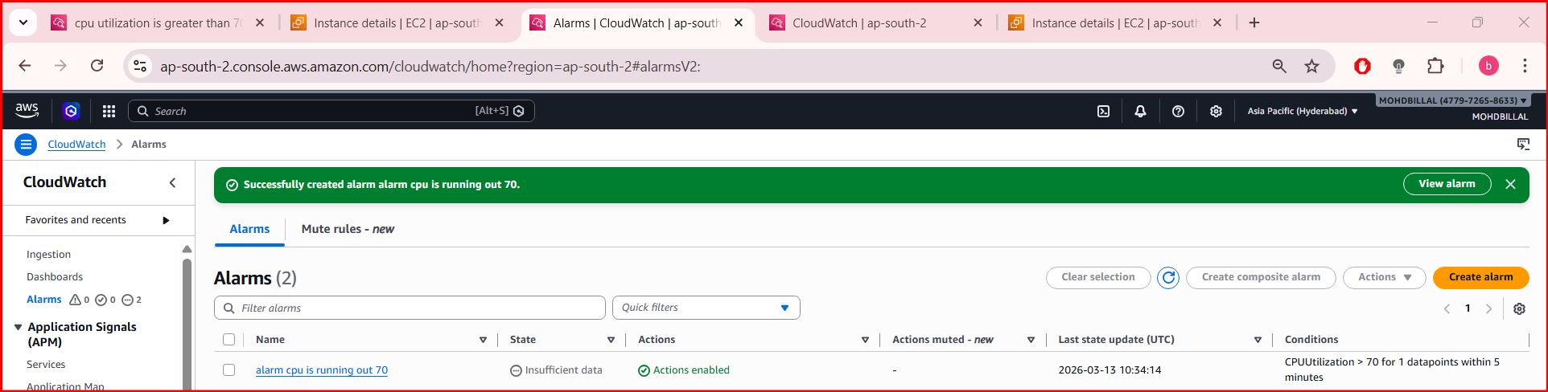
Q 6.Create a Dashboard and monitor the Nginx service to send the alert if Nginx is not running.

Step 1: Create Nginx Status Script
Login to your EC2 instance and create a script:
nano nginx_status.sh
Paste this:
#!/bin/bash
STATUS=$(systemctl is-active nginx)
if [ "$STATUS" = "active" ]; then
aws cloudwatch put-metric-data \
--metric-name NginxStatus \
--namespace CustomMetrics \
--value 1
else
aws cloudwatch put-metric-data \
--metric-name NginxStatus \
--namespace CustomMetrics \
--value 0
fi
Save and exit.

Step 2: Give Permission
sudo chmod +x nginx_status.sh

Step 3: Install Cron (if not installed)
sudo yum install cronie -y
sudo systemctl start crond
sudo systemctl enable crond

Step 4: Schedule Script (Run Every Minute)
crontab -e
Add:
* * * * * /home/ec2-user/nginx_status.sh
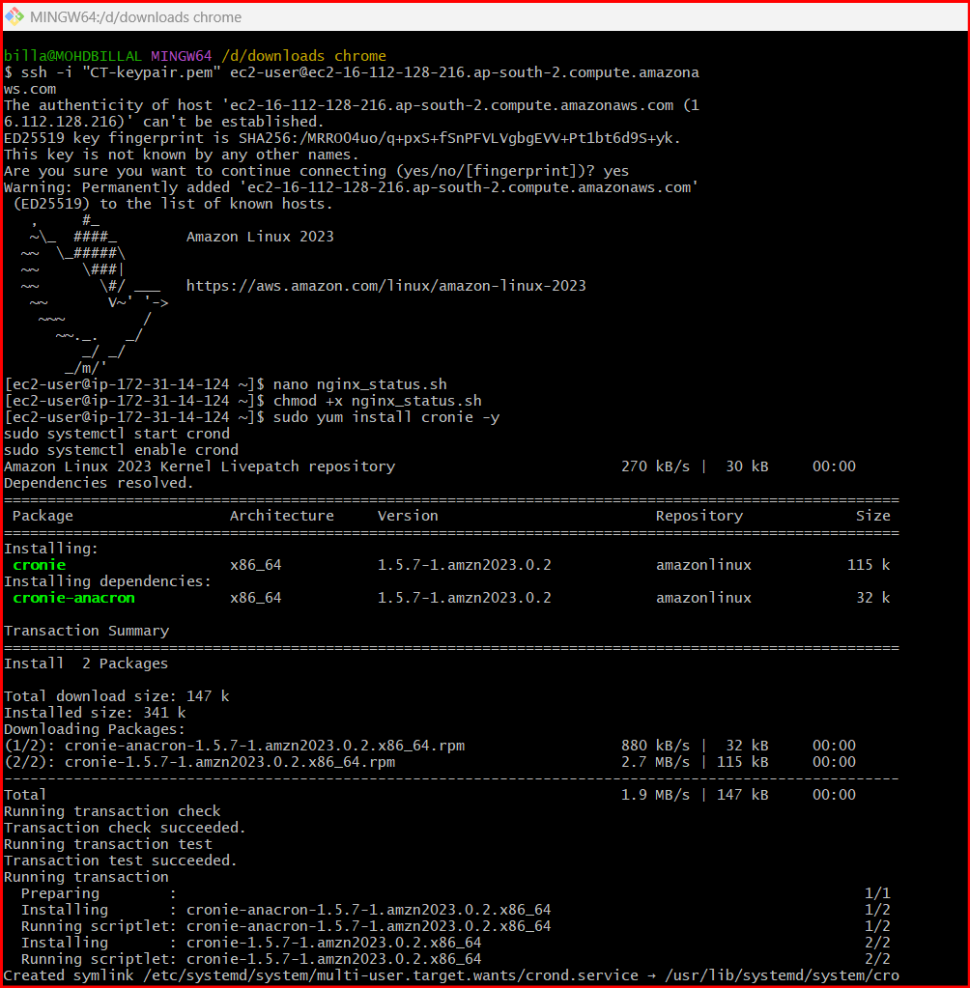

Step 5: Verify Metric in CloudWatch
- Open Amazon CloudWatch
- Go to:
Metrics → Custom Namespaces → CustomMetrics
- You should see:
NginxStatus
Values:
- 1 = Running
- 0 = Stopped
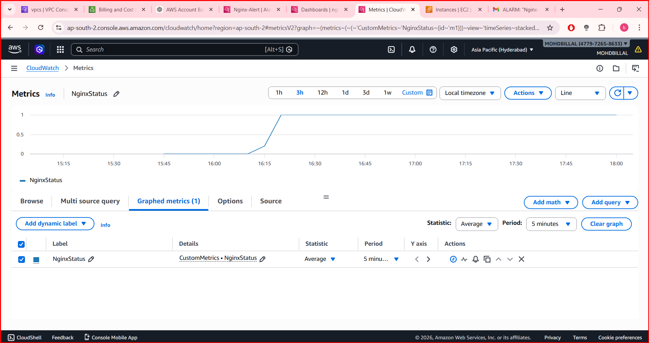

Step 6: Create Alarm
- Select NginxStatus
- Click Create alarm
Configure:
Statistic: Average
Period: 1 minute
Threshold: Less than 1
👉 If Nginx stops → value = 0 → alarm triggers

Step 7: Add Email Alert
Attach SNS topic from Amazon SNS
Example:
Topic: Nginx-Alert
Make sure your email is subscribed.
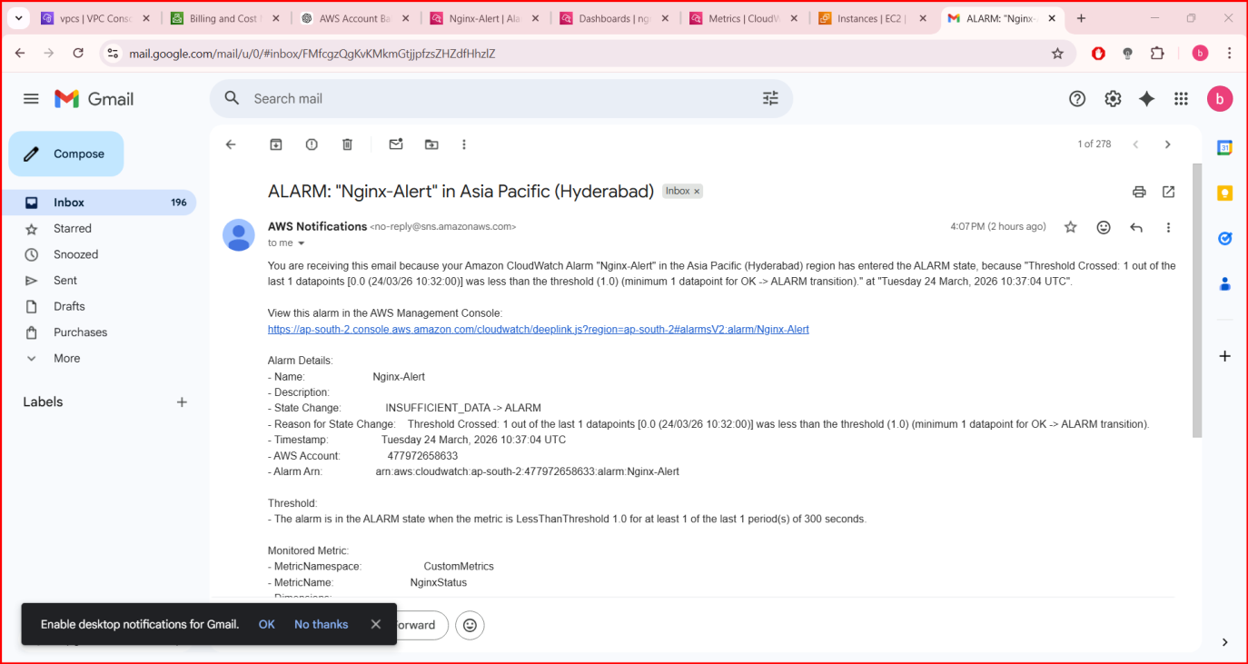

Step 8: Create Dashboard
- Open Amazon CloudWatch
- Go to Dashboards → Create dashboard
- Name:
Nginx-Monitoring
- Add widget → Line Graph
- Select:
CustomMetrics → NginxStatus

